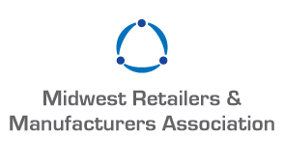

Reservation Form

MRMA Annual Dinner, Arcade & Bowling Night
Featuring the “Person of the Year” Award
Thursday, January 24, 2019

Reservation(s) _____ @ $100.00 per person Total $____________________
(Tables of 10 available for group seating)

Name(s)
Name(s)
Name(s)
Name(s)
Name(s)

____ Yes! I would like to make a $250.00 Sponsorship donation.

Corporate Sponsor Name
(Corporate sponsorship gives you signage recognition at Registration Table and bowling lanes.)

Total reservations and sponsorships $ ____________

Please make checks payable to: Midwest Retailers and Manufacturers Association
(Checks are our preferred payment method-Thank you!)

Or Credit Card # ____________________________________ Exp. Date ______________
Circle one: Mastercard, VISA or American Express

Company Name _____________________________ Phone __________________________
  Please email me a receipt for my credit card charge.

Signature __________________________________ Email* _________________________
(* Required for all registrations)

Please send reservations to: Sandy_george@comcast.net

Reservations due by Friday, January 11th

