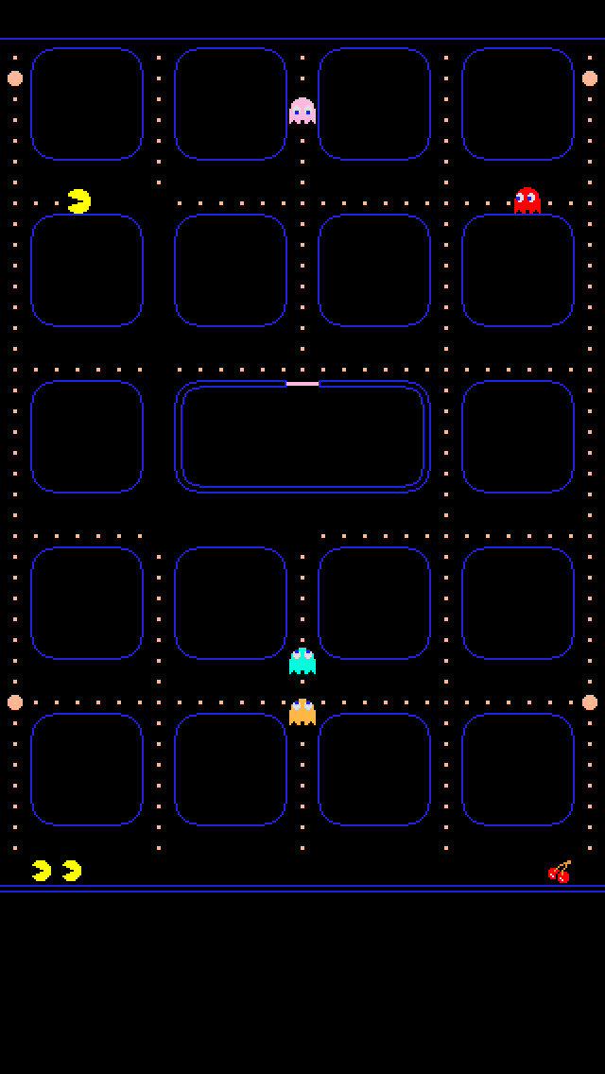
Announcing MRMA’s
“Person of the Year” Recipient

Thursday, January 24, 2019
At Level 257
2 Woodfield Mall A
Schaumburg, IL 60173

Join us as we honor
TBA

Schedule of Events
Cocktails & Dinner 5:30 pm
Welcome/Business Announcements 6:00 pm
Person of the Year Award
Arcade and Bowling Lanes Open 7:00 – 9:00 pm

$100.00 per person includes:
Family Style Dinner, 2 Drink Tickets
Game Card and Bowling

Reservations due by Friday, January 11th
Questions? Contact Alfonso Olivas @ (773) 991-7863
Or Sandy George @ (847) 275-0650

Net proceeds from this event go to the MRMA Scholarship Fund

